**AI POWERED RESUME BUILDER**

Aman Sehgal, Anant Dapurkar, Love Kumar, Megha Mishra

*Computer Science and Engineering, Chhattisgarh Swami Vivekanand Technical University, India*

*Computer Science and Engineering, Chhattisgarh Swami Vivekanand Technical University, India*

*Computer Science and Engineering, Chhattisgarh Swami Vivekanand Technical University, India*

*Computer Science and Engineering, Chhattisgarh Swami Vivekanand Technical University, India*

[sehgalaman34@gmail.com](mailto:sehgalaman34@gmail.com), [lovekumar30460@gmail.com](mailto:lovekumar30460@gmail.com), [dapurkaranant@gmail.com](mailto:dapurkaranant@gmail.com)

[megha16shukla@gmail.com](mailto:megha16shukla@gmail.com)

***Abstract—* This research paper presents the design and implementation of an AI-powered resume builder aimed at simplifying the resume creation process for job seekers. By leveraging artificial intelligence techniques such as natural language processing (NLP), the system automates content generation, grammar correction, and skill-job alignment. This paper outlines the motivation, architecture, implementation, and testing of the system, highlighting its efficiency and real-world applicability.**

# *Keywords—* Resume Builder, Artificial Intelligence, Natural Language Processing, Job Matching, Automation.

# I. INTRODUCTION

Creating a well-structured and professional resume is often a time-consuming process for fresh graduates and professionals alike. An AI-powered resume builder streamlines this process by generating customized resumes tailored to job roles. This paper proposes a solution that automates and simplifies resume building using modern AI technologies.

# II. LITERATURE REVIEW

Several online platforms like Zety, Novoresume, and Canva provide resume-building services. However, these tools are often template-driven with limited AI capabilities. Recent advancements in NLP and machine learning have enabled more intelligent resume parsing and recommendation systems. Our proposed system fills the gap by integrating AI-driven content generation and job matching.

# III. SYSTEM ARCHITECTURE

The architecture includes a user interface for input, a backend for processing, and an AI module for natural language handling. It follows a modular design, ensuring scalability and flexibility for future enhancements.

# IV. TECHNOLOGIES USED

1. *Frontend (User Interface)*

• HTML, CSS, JavaScript – Basic structure and styling

• React.js – For dynamic and responsive UI

1. *Backend (Server-side Processing)*

• Node.js with Express – For handling API requests

1. *Database*

• MongoDB – For storing user data (NoSQL)

1. *Artificial Intelligence & NLP*

• Google Gemini: Multi-model AI by Google Deepmind/NLP Models – For text generation and content suggestions

# V. IMPLEMENTATION

The system offers the following features:

|  |  |  |
| --- | --- | --- |
|  | **Feature** | **Description** |
| I. | AI Resume Generator | Generates content based on job role and user input |
| II. | Skill Matcher | Matches user skills with job description |
| III. | Grammar Correction | Uses NLP to correct language and grammar |
| IV. | Template Export | Downloads resume in clean PDF format |

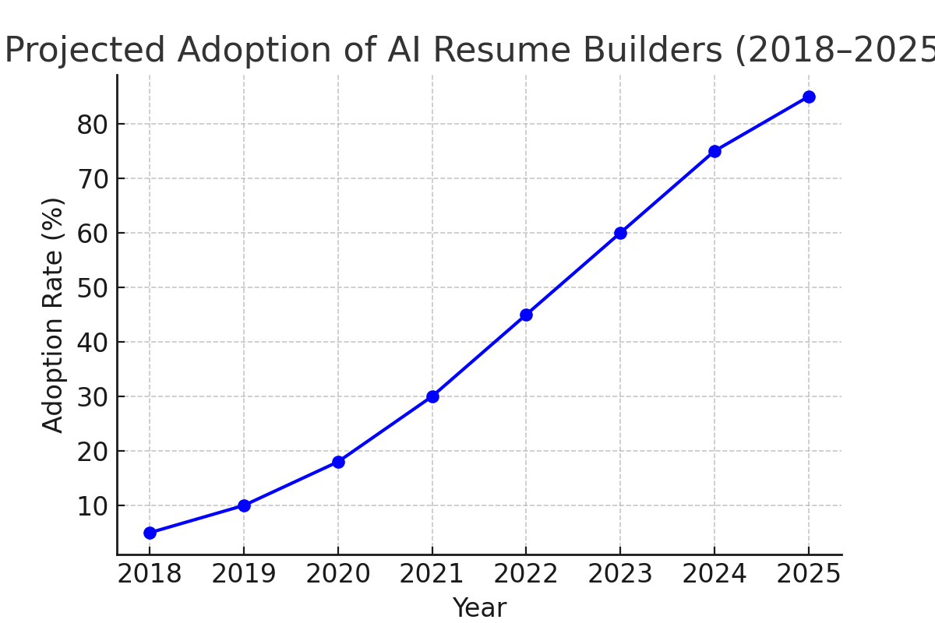

Fig 1: Projected Adoption of AI Resume Builders (2018–2025)

# VI. RESULTS AND EVALUATION

The AI Resume Builder was rigorously self-tested by the development team at Shri Shankaracharya Technical Campus. Testing was conducted during each stage of development to ensure that core functionalities—including AI-driven resume generation, skill-job alignment, grammar correction, and PDF

Due to time constraints and academic scope limitations, no third-party user testing or formal usability studies were conducted. However, extensive manual testing covered a wide range of inputs and job description scenarios. These self-evaluations confirmed the tool’s robustness, reliability, and overall performance under typical use cases. Future work may involve structured user studies to assess real-world effectiveness and improve the system based on direct user feedback.

# VII. CONCLUSION

The AI-powered resume builder provides a smart and efficient way for users to create professional resumes with minimal effort. Through the integration of AI, the system can generate job-specific content and assist users in matching their profiles to potential job roles. Future improvements may include user feedback integration, multi-language support, and advanced resume analytics.

# ACKNOWLEDGEMENT

We express our sincere gratitude to Dr. Megha Mishra for her guidance and support throughout this project. We also thank the faculty and technical staff of Shri Shankaracharya Technical Campus, Bhilai, for providing necessary resources and encouragement.

# REFERENCES

[1] OpenAI. ChatGPT https://openai.com/chatgpt.

[2] Novoresume. Online Resume Builder. https://novoresume.com.

[3] Canva. Resume Templates. https://canva.com/resumes.

[4] Zety. ResumeBuilder. https://zety.com/resume-builder.